NAMA : M AL FAIZ PUTRA JALASENANDRA

NIM : 21091397072

Praktikum 1

1. #include <conio.h>

using namespace std;

int main()

{

int i, n, data[5];

float rata,jum;

cout<<"Masukan banyaknya data = ";

cin>>n;

cout<<endl;

for (i=0; i<n; i++)

{

cout<<"Data ["<<i+1<<"] = ";

cin>>data[i];

jum += data[i];

}

rata=jum/n;

cout<<endl;

cout<<"Banyaknya data = "<<n<<endl;

cout<<"Rata-rata = "<<rata<<endl;

cout<<"Jumlah = "<<jum<<endl;

getch();

}

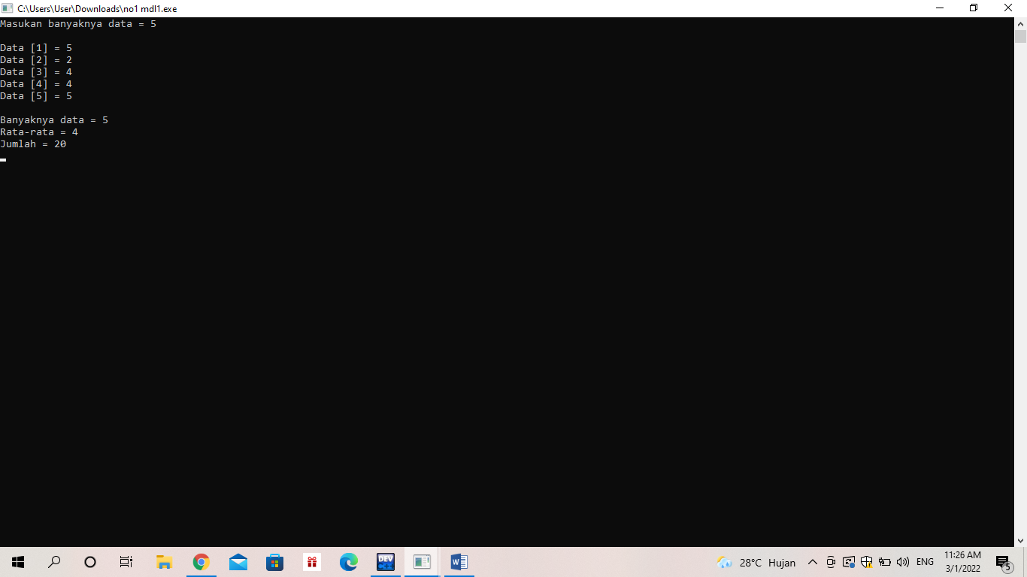

2. #include <iostream>

#include <iomanip>

using namespace std;

int main()

{

int kode[5]={001, 002, 003, 004, 005};

string nama [5]={"Penghapus", "Pensil", "Buku", "Rautan", "Penggaris"};

int jumlah [5] = {4,3,2,3,5};

int harga [5]= {1000,1500,2000,1000,500};

int total [5];

int jumlah_barang=0;

int jumlah_total=0;

cout<<"Kode\tNama\t\tJumlah\tHarga\tTotal"<<endl;

for (int i=0; i<5; i++)

{

total[i]= jumlah[i]*harga[i];

cout<< setfill ('0') << setw (3)<< kode[i] << "\t" << nama[i] << " \t" << jumlah[i] << " \t" << harga[i] << "\t" << total[i] << endl;

jumlah_barang= jumlah_barang+ jumlah [i];

jumlah_total= jumlah_total+ jumlah [i];

}

cout<< "Jumlah item = 17\n";

cout<< "Total pembelian = 18000\n";

}

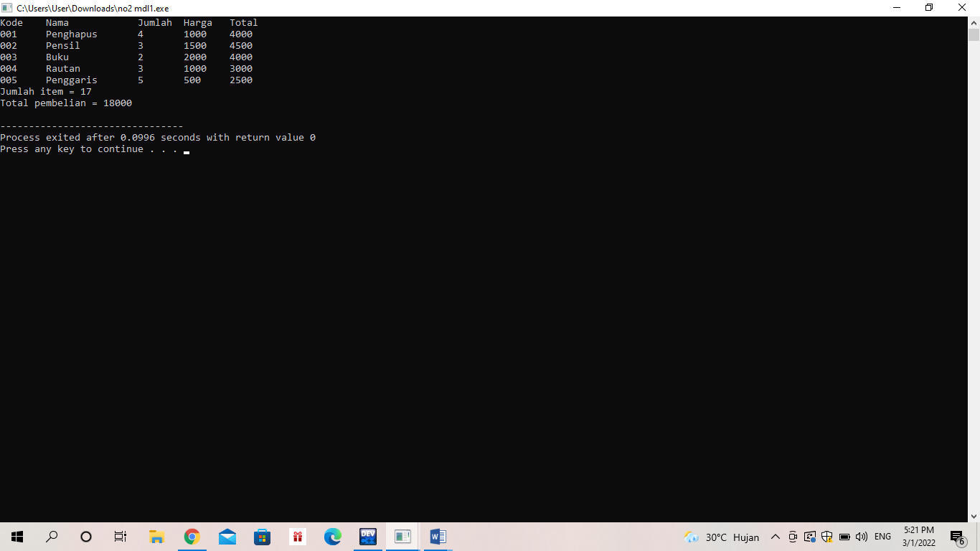

3. #include <iostream>

#include <conio.h>

#include <math.h>

using namespace std;

int main(){

int x, jumlah=0;

float rata;

cout << "Masukkan banyak data : ";

cin>>x;

int d[x];

for(int i=0 ; i<x ; i++){

cout << "Data [" << i+1 << "] = ";

cin >> d[i];

jumlah += d[i];

}

rata=jumlah/x;

cout << "Banyak data : " << x << endl;

cout << "Rata-rata : " << rata << endl;

cout << "Jumlah : " << jumlah<<endl;

float sigma = 0;

for (int i=0 ; i < x ; i++){

sigma += pow((d[i] - rata), 2);

}

float sd = (float) sqrt (sigma/x);

cout << "Hasil sd\t : " << sd;

return 0;

}

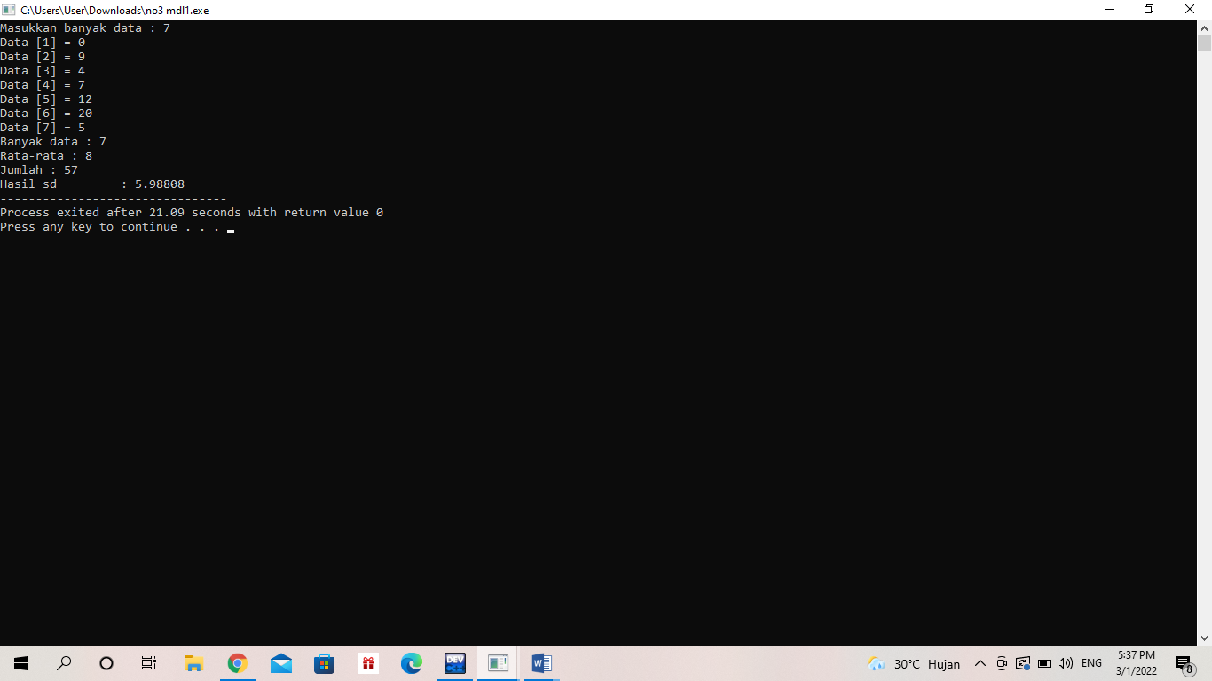

4. #include <iostream>

using namespace std;

void cetakMatrixA(int mA[2][2]){

for(int i=0; i<2; i++){

for(int j=0; j<2;j++){

cout<<mA[i][j]<<"";

}

cout<<endl;

}

}

void cetakMatrixB(int mB[2][2]){

for(int i=0; i<2 ;i++){

for(int j=0; j<2; j++){

cout<<mB[i][j]<<"";

}

cout<<endl;

}

}

void perkalian(int mA[2][2], int mB[2][2], int mHasil[2][2]){

int jmlh = 0;

for (int i = 0; i < 2; i++){

for (int j = 0; j < 2; j++){

for (int k = 0; k < 2; k++){

jmlh = jmlh + (mA[i][k] * mB[k][j]);

}

mHasil[i][j]=jmlh;

jmlh =0;

}

}

}

void cetakPerkalian(int mHasil[2][2]){

for (int i = 0; i < 2; i++){

for (int j = 0; j < 2; j++){

cout << mHasil[i][j] <<"";

}

cout<<endl;

}

}

int main(){

int matrixA[2][2];

int matrixB[2][2];

int matrixHasil[2][2];

matrixA[0][0] = 3;

matrixA[0][1] = 4;

matrixA[1][0] = 1;

matrixA[1][1] = 2;

matrixB[0][0] = 7;

matrixB[0][1] = 5;

matrixB[1][0] = 6;

matrixB[1][1] = 4;

cout <<"Matriks A : "<< endl;

cetakMatrixA(matrixA);

cout << endl;

cout <<"Matriks B : "<< endl;

cetakMatrixB(matrixB);

cout << endl;

cout <<"Hasil Perkalian Matriks A & B : "<< endl;

perkalian(matrixA, matrixB, matrixHasil);

cetakPerkalian(matrixHasil);

return 0;

}

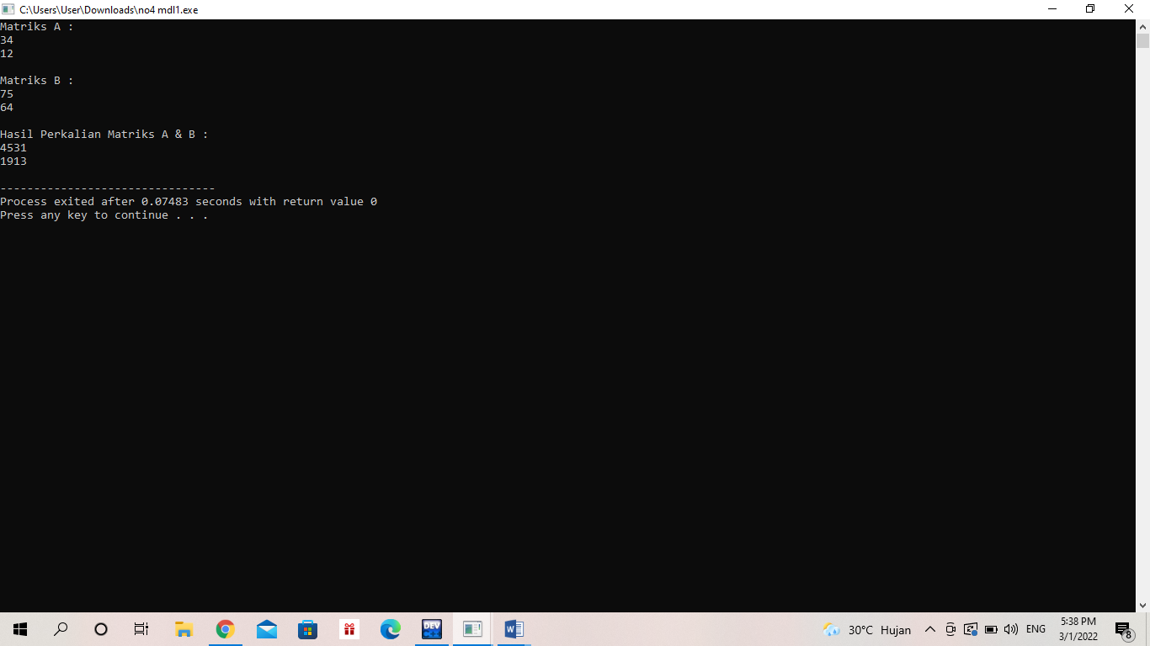

4. masih berusaha lebih baik

5.